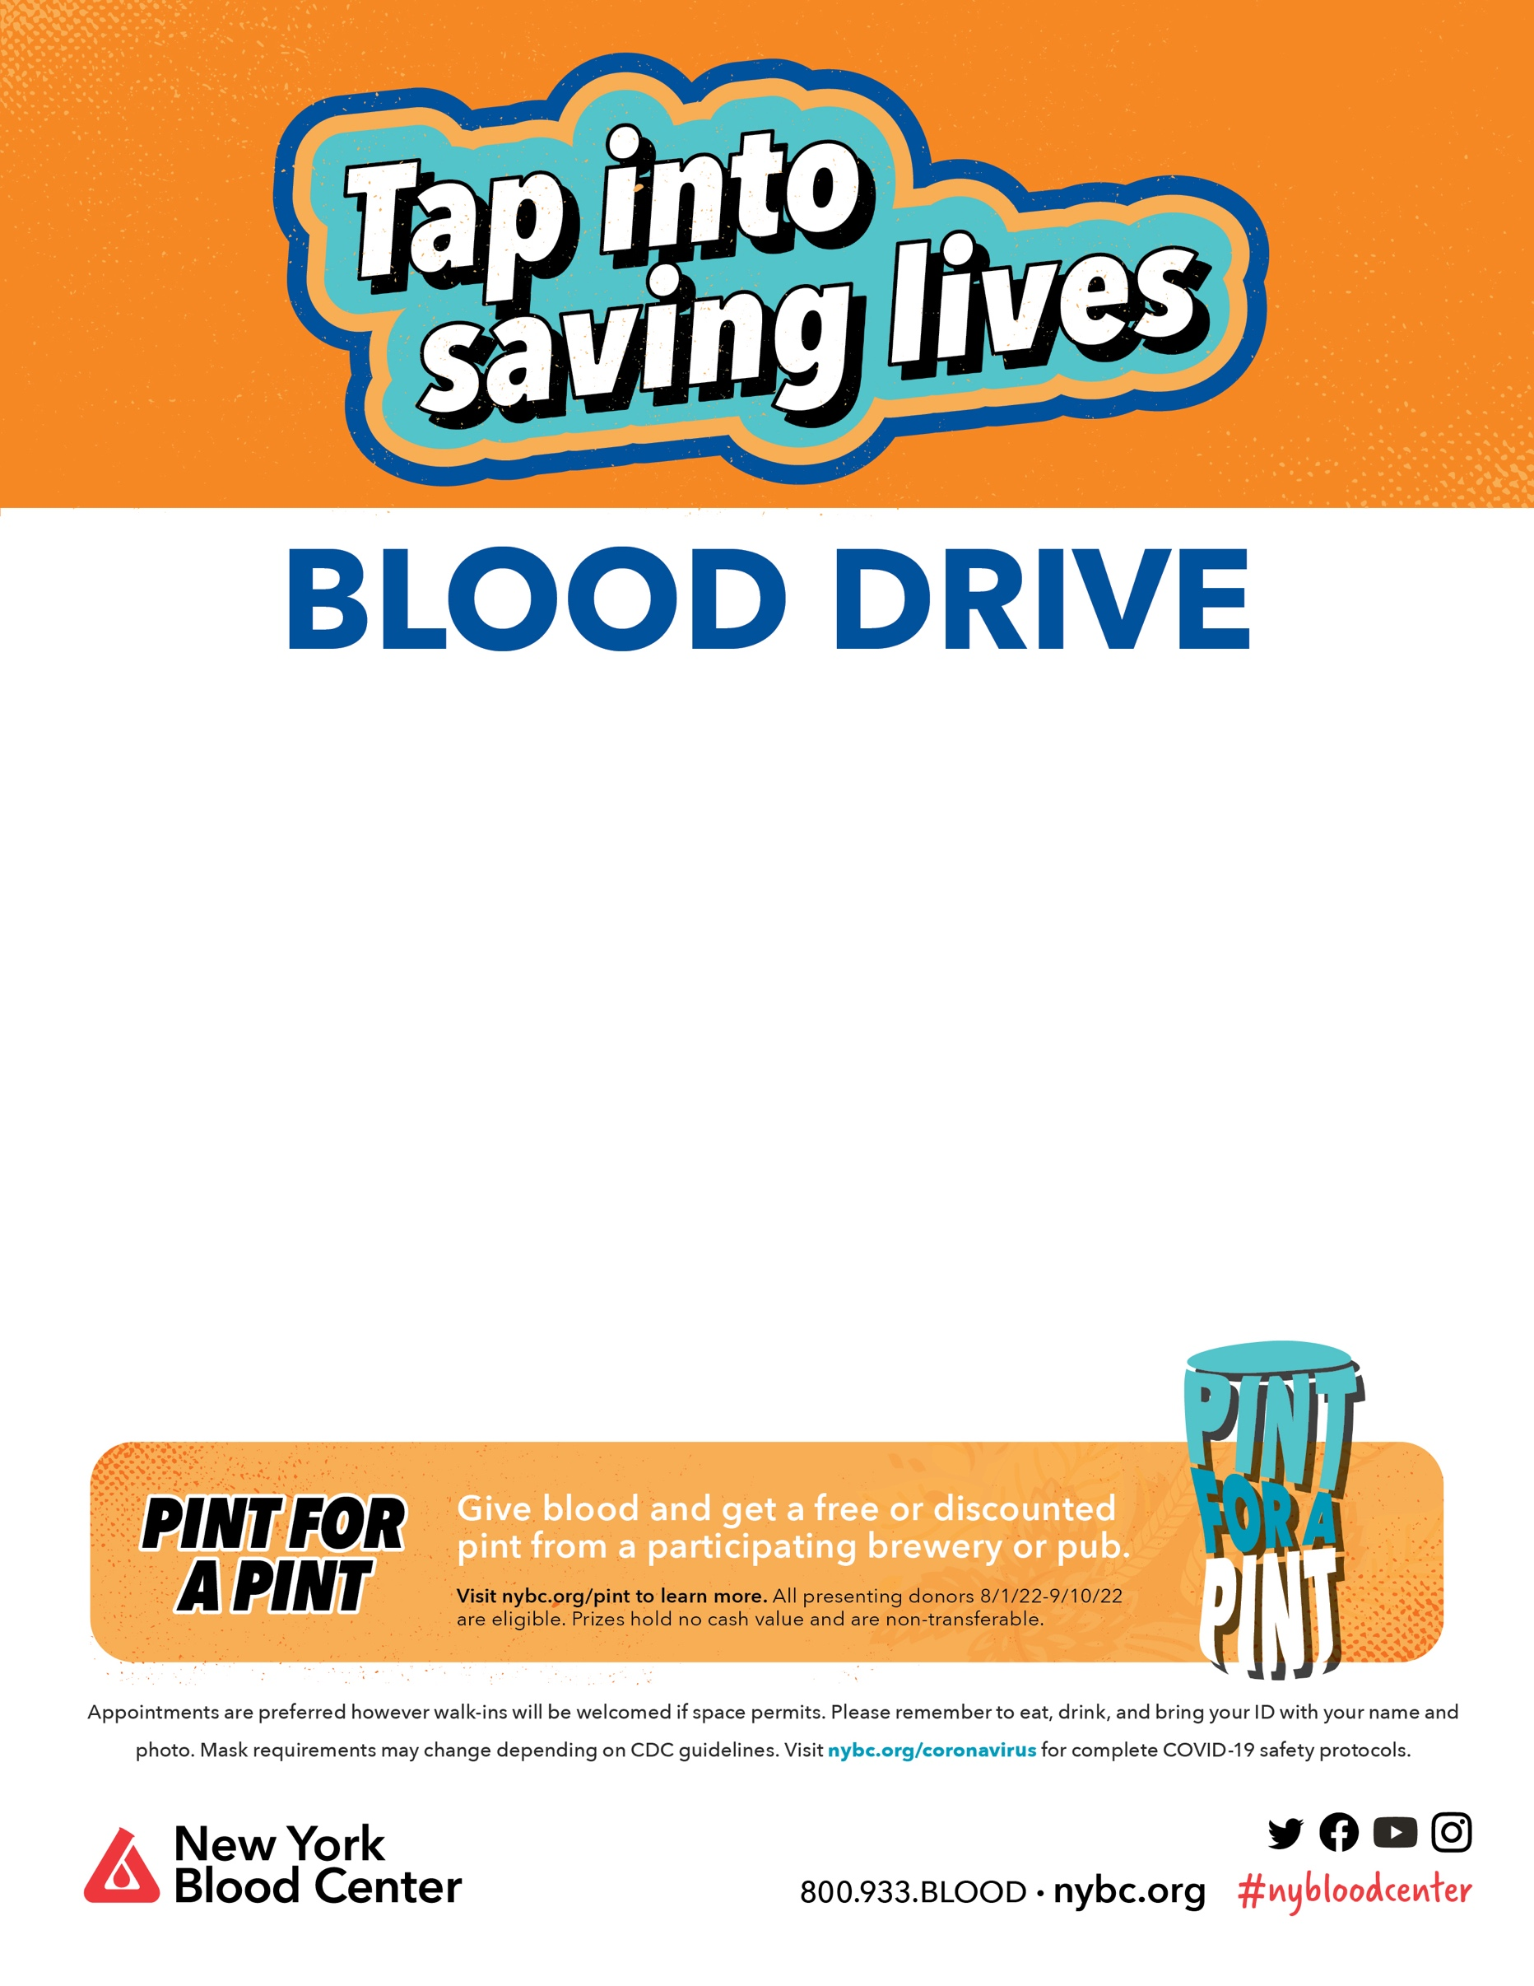­­­

**Bloodstock William Miller**

**Shoreham Wading River High School**

**Monday, August 22 / 1-7 PM**250B Rt. 25A, Wading River- Cafeteria

**Pint for a Pint- All donors will receive a voucher for a free pint at participating breweries across Long Island!**

**(Under 21- will receive a McDonald’s voucher)**

**Appointments are preferred but walk-ins are welcome if social distancing permits!** To make an appointment scan the QR code above,

OR call 1-800-933-2566/ www.nybc.org

**Any further questions contact Kristen Reutter at 1-646-739-1827**